Virtual Artist Interview
  - Volume 1 / Issue 1
(Write an interesting lead
Use an interesting point from your interview here to make the reader want to dig deeper.)
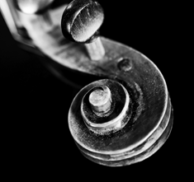
[Click here to add a caption]

(Put Your Title of Your interview here)
(Replace all information in parentheses with your own for the interview. All of YOUR questions and comments should be in bold letters – delete these instructions and parentheses before submitting your interview)
- (Your Intiials): (your initials signify you are talking, Introduce yourself to the artist, your position and experience, and tell the artist why you have chosen the work you have to review with him/her in this interview. State your desired education intended qualifications. Use the title of the work, in quotes or italics, when writing the title, and mention which museum it is located in, the town, whether it is in the museum's permanent collection or whether the work is temporarily, but physically on view in a museum exhibition. Decide for yourself what impresses you about the work or what you think is "off the mark". You may also want to ask if the artist is dead, alive and if there are any details he would like to share about his current situation.

- (Artist’s Initials): (artist's initials will signify he is talking)

- (your initials signify you are talking): You may always disagree, because you are the curator! Ask about the process or form in which the artist prefers working and which media is used in this particular work. (Is it a painting, sculpture, photograph, video, installation...?)

- (artist's initials signify he is answering your question and may have a question of his own for you):

(your initials signify you are talking): Ask the artist what makes his work important today? Was it "a first," or did it somehow change the perception of art over time? If you, the curator, have an opinion about the work's place in art history, ask the artist if he agrees or disagrees and why

- (artist's initials signify he is answering your question):

- (your initials signify you are talking): What elements in this work does he think was/is inspired by another art movement, locally, or in a different location in the world, or a different time period, such as period styles like Cubism, Impressionism, or Baroque?

- (artist's initials signify he is answering your question and may want to know why you think it matters):

- (your initials signify you are talking): Determine the subject matter in the artwork and see if the artist agrees. Ask if the artist's work has changed in any considerable way since this work was made. Tell the artist why you think this work of art has value in the world today and see what he says.

- (artist's initials signify he is answering your question):

- (your initials signify you are talking): Choose a word from the Student-Made Glossary in the TALK section and ask the artist if it is true that it has a relationship to his own work or not. End with a closing remark, and thank you.

(“Call out an important point or quote from your artist.”) – (Artist’s Name)

Get the Picture
Replace a sample picture with a picture of the artist’s work. To replace, right-click on the picture and then click Change Picture.
If your picture isn’t a perfect fit for the space provided, you can crop it in almost no time. On the Picture Tools Format tab, click Crop.
Want to zoom in on the best part of your photo and make it stand out even more? After you click Crop, just drag to resize the image inside the crop area.

Continued
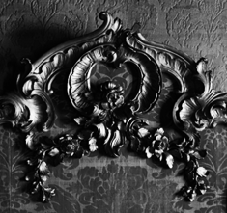
[Click here to add a caption]
For example, if article text gets too long for the first page, it will automatically flow onto this page – leaving the rest of the great-looking layout just as it is.
In the picture block to the left, add a picture of the artist using the instructions for the first picture.

Writer’s bio
Include information about yourself – fictional or non-fictional. Include where you were born, where you live, and your educational qualification for being a curator (You, the Art Curator) and your experience.
To add another page, just click in the last sentence of the sample story above this one and then press Ctrl+Enter.

[Click here to add a caption]
Add a picture of You, the Art Curator.

